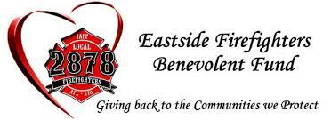

1st Annual Eastside Firefighters Charity Invitational Rules & Details

Golf Rules & Details:
- $400 Team registration fee includes:
  - Middle Fork Roasters Coffee
  - Rhodies BBQ box lunch
  - 2 drink tickets for Big Block Brewery
- 4-person scramble, tee times, NO SHOTGUN
- 3 tee shots minimum per person, per team
- Maximum 2 putts per hole. (An eagle putt = a birdie score at worst)

$40 Mulligan Package Includes:
- 4 mulligans for team
AND
- 2 tee shots on all long drive holes and closest to the pin holes

On Course Games
- 2 long drive contests per course (4 total)
- 2 closest to the pin contests per course (4 total)
- 18th hole (over the water shot)
  - Details covered day of

Sponsors
- Middle Fork Roasters – Coffee provided at the registration table, starting at 8am
- Rhodies BBQ – Sandwiches provided on the course, starting at 1030am
- Big Block Brewery – Beer provided on the course, at the turn, and after your round of golf

